JMP notes on ANCOVA

Example study is the deLury toxicology study: 4 treatments, 4 rats per treatment, CRD

Body weight measured before start of treatments (initial) and after 4 days (final).

The data is in delury.xlsx

Most of the model setup is obvious after what we’ve been doing. These instructions concentrate on interpreting the results and reminding you about extensions.

Basic ANCOVA (same slope) model:

Make sure that treatment is a nominal (red bar) variable and initial is a continuous (blue ramp) variable.

Add both variables to the Construct Model Effects box, put final in the Y box, then run the model.

JMP automatically produces a plot of the lines when you have one covariate and one factor in the model. Remember you can save all the output in a JMP journal, then copy the plot from the journal to a Word document.

The output in the first column includes Effect Tests. These are type III tests. Treatment is the test of equality of treatment means, when evaluated at the same value of the covariate (initial). Initial is the test of the pooled within treatment slope = 0.

If you want the estimated slope, look in the parameter estimates box. The intercept and treatment parameters require some care and understanding to interpret, because the effects model for treatments is overparameterized. This was discussed in the material on factorial ANOVA. The slope for initial is uniquely identified, so is easy to interpret. The slope for these data is 0.855 with a standard error of 0.082.

If you want a confidence interval for the slope, go to the red triangle by Response final, select regression reports, and click Show all confidence intervals. The parameter estimates box will now include the 95% confidence interval.

The lsmeans box for treatment has the mean for each treatment at the average covariate value. I have not found a way in JMP to easily get lsmeans for values other than the average covariate value. If you need those for research, they can be obtained as predictions for new observations.

**Adding a quadratic term to the model.**

This provides a way to test whether a straight line is adequate. If the quadratic term is significant, the straight line is not adequate.

The best way to add a quadratic term is to create it in the model effects box. That way JMP “knows” that X and X^2 are related. Analyze / Fit Model, then add the covariate and the categorical variable to the model box. Select initial in the columns and initial in the model box and click cross (just like you would to create an interaction). The interaction of a continuous variable with itself is the squared term. Some of you may remember “center polynomials” from 587. You can leave this checked (the default) or uncheck it. Since we’re mostly interested in the quadratic term, centering doesn’t matter. Then run the model.

Tests of quadratic coefficient = 0 are provided in two places. The T test of the quadratic estimate in the Parameter Estimates box and the F test of the quadratic term in the Effect Tests box. In both cases, the p-value is 0.397 so there is no evidence of lack of fit to a straight line. A straight line is adequate.

**Heterogeneous regression lines (different slopes)**

Start with the basic ANCOVA model and add the interaction to the Construct Model Effects box. Here’s how you construct an interaction, in case you don’t remember. Put treatment and initial in the model effects box, then select treatment and initial in the Select columns box and click Cross by the Model Effects box. Treatment*initial will be added to the model effects box.

Before doing anything more, click the red triangle by Model Specification (top left). Notice that Center Polynomials is checked. This is the default for JMP. Uncheck Center Polynomial, then run the model.

The Effect Tests box has type III tests. The interaction tests whether the slopes are equal. Here, no evidence of unequal slopes (p = 0.73). When Center Polynomials **was not checked**, the treatment test tests whether treatments have the same intercept. The covariate (initial) test tests whether the average slope is 0. If you leave Center Polynomials checked, the treatment test becomes a jumble and I can’t interpret it.

If you are unsure whether or not Center Polynomials was checked, look at the parameter estimates. If the interaction terms have a subtraction (see below for an example), polynomials were centered. JMP has subtracted the average value from the covariate before using it in an interaction. This sounds like, and could be, a very good idea. The problem is that JMP doesn’t also subtract it from the covariate main effect term.

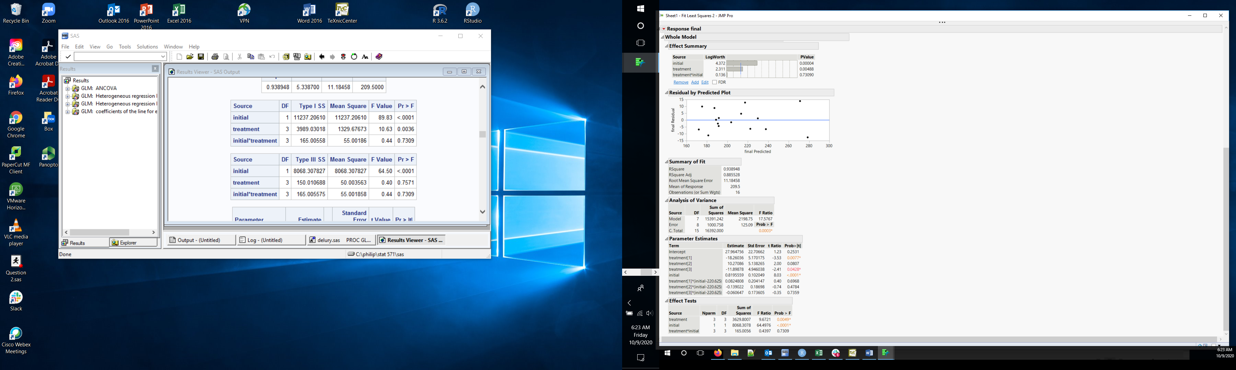

The other useful output is the table of lsmeans for each treatment. Those are the treatment means **at the average covariate value**. They have the same values whether or not polynomials were centered. You can do all the usual things (contrasts, pairwise differences) with these lsmeans.

**Analyzing differences**

We need to calculate final – initial and store that in a new column. I will call that new variable diff. You can compute diff in Excel before importing the data into SAS. Or, you can calculate it in JMP. The procedure to calculate a new variable is essentially the same used to calculate transformed values in JMP. My Stat 587 instructions here: <https://pdixon.stat.iastate.edu/stat587/labs/JMP/Lab%205.docx> have detailed directions with screen shots describing how to compute new variables in JMP. Here’s a quick summary.

In the JMP data window, right click at the top of a blank column, select new column. Provide a name, e.g. diff, that is more informative than the default “column #” in the Column Name box. Then click the Column Properties box (bottom left of the dialog window). The top entry in the drop-down menu is Formula. Select Formula. This opens the formula window.

The formula window allows you to enter a formula using the mouse. You have many choices of operations (in the left most column), can choose variables (next column to the right) and basic math operations in the menu bar at the top. The formula window opens with no formula inside a blue box in the middle of the main panel. We want to calculate final – initial. To do this:

Click final in the list of variables. You will see that final has moved into the blue box.

Click the – in the top row of math operations. You will see that the formula now reads final – with an empty blue box after the -.

Click initial in the list of variables. You will now see the formula you want: final – initial

Click OK. You will see a new column in the data window, labelled diff with values that are the difference final – initial.

The New column dialog remains open in case you want to create more than one variable. We don’t, so click ok to get rid of the dialog.

You can now use diff as the response variable in any statistical analysis, e.g. fitting a one-way ANOVA.